Library Online “elibrary.edu”

**Design Document**

**Version 1.0**



**Group Id: F210273AE8**

**Supervisor Name: Abdul Majid Khokhar (abdulmajid@vu.edu.pk)**

**Revision History**

|  |  |  |  |
| --- | --- | --- | --- |
| **Date (dd/mm/yyyy)** | **Version** | **Description** | **Author** |
| 7th/Feb/2022 | 1.0 | E-Library is a digital library website, where users can find books according to their needs by using filters and easily read books. E-Library maintains the information about the books, their authors, and members of a library which is very complex to maintain the information manually. E-library helps in many instances of maintenance. It will reduce the manual workload. | BC180408671,  BC180203457 |
|  |  |  |  |
|  |  |  |  |
|  |  |  |  |

**Table of Contents**

1. Introduction of Design Document
2. Entity Relationship Diagram (ERD)
3. Sequence Diagrams
4. Architecture Design Diagram
5. Class Diagram
6. Database Design
7. Interface Design
8. Test Cases

Introduction of Design Document

The design document is used to provide the documentation aid in software development providing the detail of how the system should be built. This document contains the contextual as well as the visual design of the application. This design activity provides a roadmap for the completion of the project and will make sure the achievement of the requirements of the project and let the project be the final deliverable stage.

The reason behind writing this document is to provide you with a graphical and textual design of the E-Library. This document briefly explains to you the application design with the help of several design diagrams including ERD diagram, sequential diagram, database diagram, and architecture diagram.

Entity Relationship Diagram (ERD))

<Provide Entity Relationship Diagram (ERD) of your system>

Sequence Diagrams

|  |
| --- |
| Sequence Diagram for Admin |
| For Login |
|  |
| For adding books |
|  |
| For updating books |
|  |
| For deleting books |
|  |
| For adding categories |
|  |
| For updating setting |
|  |
| For deleting categories |
|  |
| For view user |
|  |
| For view books |
|  |
| For update setting |
|  |
| For logout |
|  |

|  |
| --- |
| For User/Reader |
| Login |
|  |
| Read Book |
|  |
| Add / Remove to book shelf |
|  |
| Search |
|  |
| Explore Categories |
|  |
| Update setting |
|  |
| Logout |
|  |

|  |
| --- |
| For Visitor |
| View Website |
|  |
| For Preview book |
|  |
| For Searching |
|  |
| For Registration |
|  |

Architecture Design Diagram

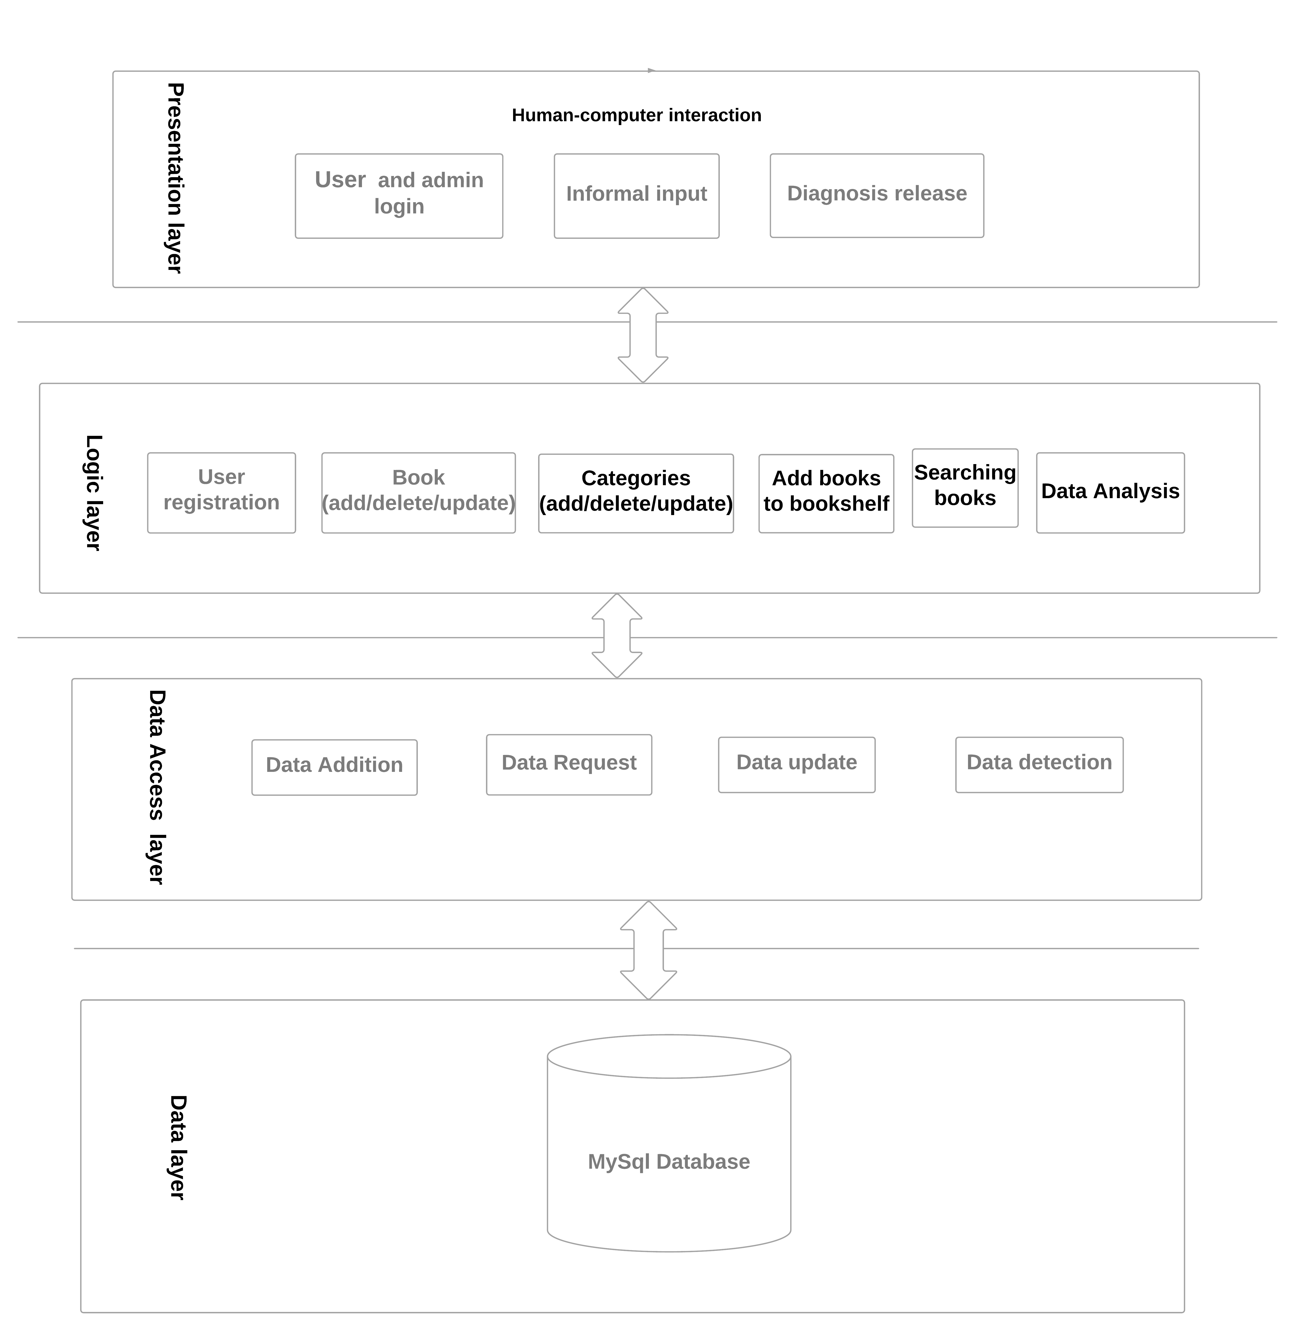

Class Diagram

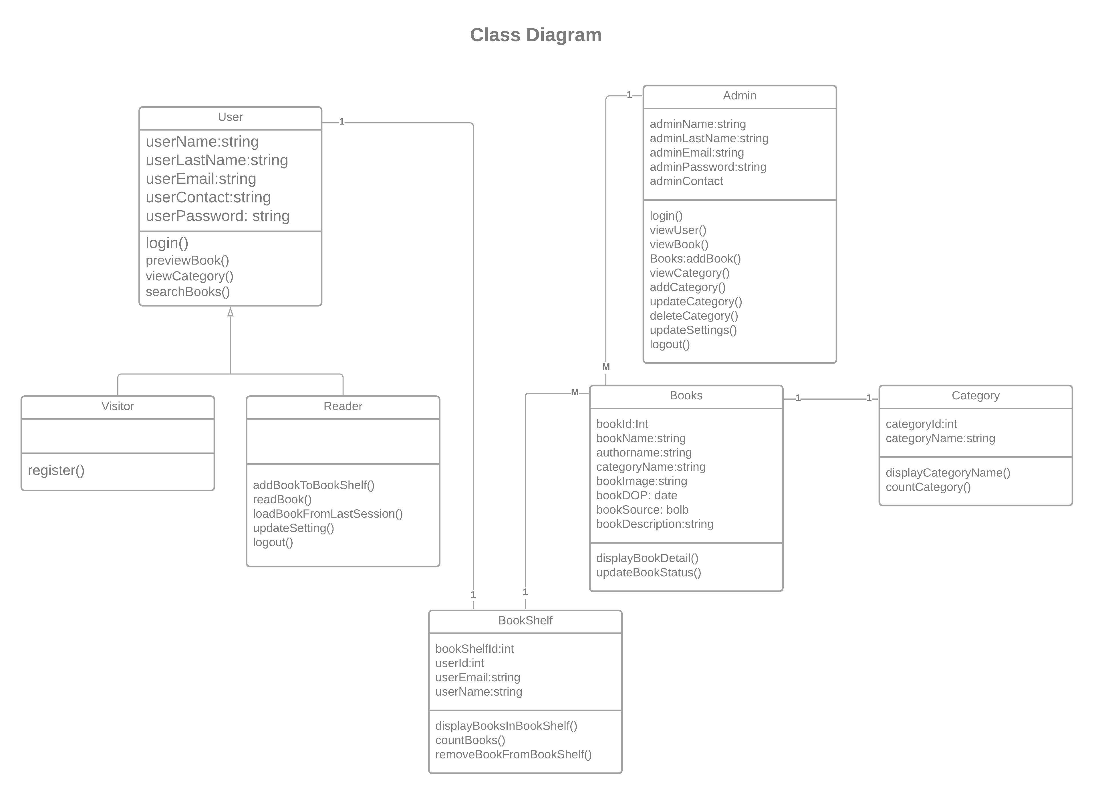

Database Design

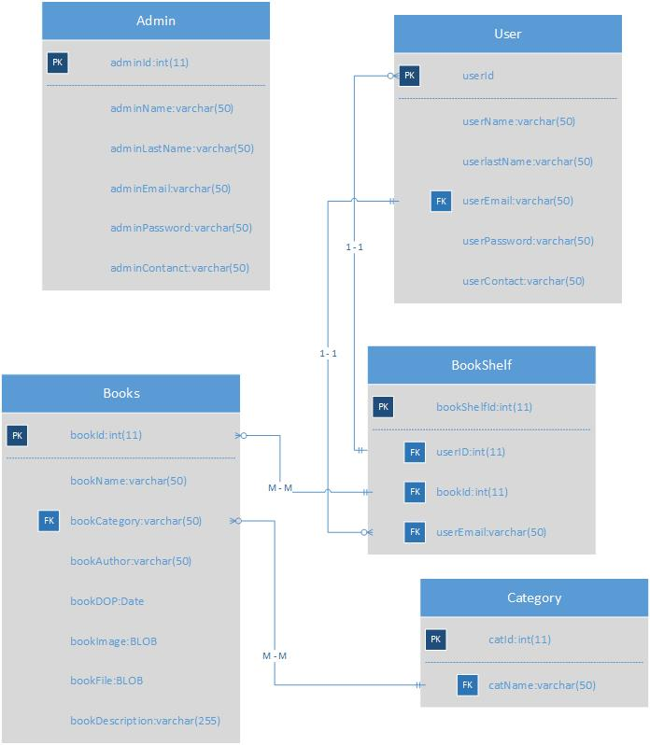

Interface Design

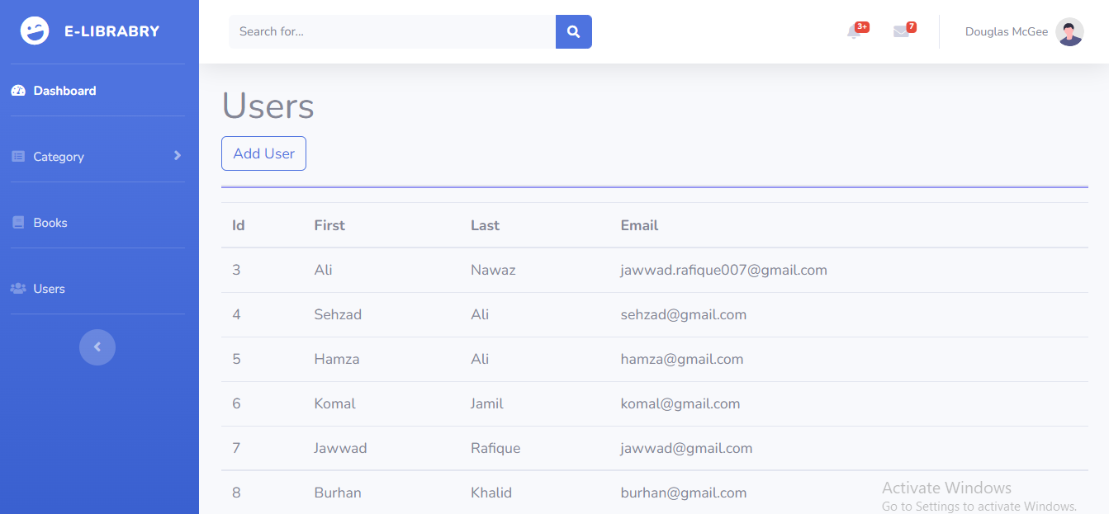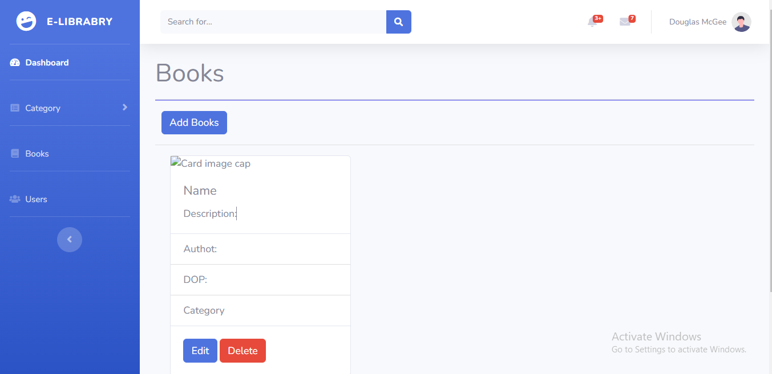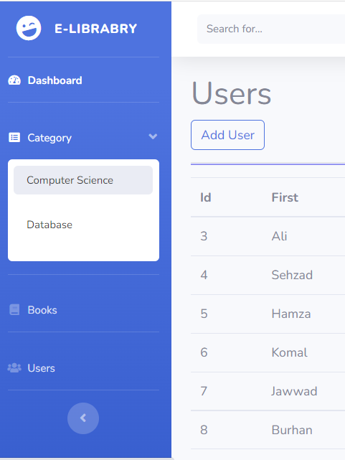

Test Cases

|  |  |
| --- | --- |
| Test Case Id | ELTC1 |
| Test Case Title | Registration with invalid information |
| Test Case Description | Visitor register himself by filling up registration form to get user right(reading books, adding book to book library etc) |
| Test Steps | 1. Visitor click registration link. 2. Visitor fills the registration form. 3. Visitor click submit button |
| Pre-Condition | Internet must be available.  Registration form must be opened. |
| Post-Condition | If error occurs it should be shown clearly. |
| Expected Result | Registration failed |
| Actual Result | Registration failed because of invalid information |
| Pass/Fail | Pass |
| Tested By | BC180203457 (Komal Jameel) |

|  |  |
| --- | --- |
| Test Case Id | ELTC2 |
| Test Case Title | Registration with email id that already exits |
| Test Case Description | Visitor register himself by filling up registration form to get user right(reading books, adding book to book library etc) |
| Test Steps | 1. Visitor click registration link. 2. Visitor fills the registration form. 3. Visitor click submit button |
| Pre-Condition | Internet must be available.  Registration form must be opened. |
| Post-Condition | If error occurs it should be shown clearly. |
| Expected Result | Registration failed |
| Actual Result | This user id is already exist |
| Pass/Fail | Pass |
| Tested By | BC180203457 (Komal Jameel) |

|  |  |
| --- | --- |
| Test Case Id | ELTC3 |
| Test Case Title | Registration with valid information |
| Test Case Description | Visitor register himself by filling up registration form to get user right(reading books, adding book to book library etc) |
| Test Steps | 1. Visitor click registration link. 2. Visitor fills the registration form. 3. Visitor click submit button |
| Pre-Condition | Internet must be available.  Registration form must be opened. |
| Post-Condition | If error occurs it should be shown clearly.  If registration successfully done redirect user to home page. |
| Expected Result | Registration successful |
| Actual Result | Registration complete successfully |
| Pass/Fail | Pass |
| Tested By | BC180203457 (Komal Jameel) |

|  |  |
| --- | --- |
| Test Case Id | ELTC4 |
| Test Case Title | Login with invalid information |
| Test Case Description | Reader login himself by providing login credentials user account. |
| Test Steps | 1. Reader click login link. 2. Reader fills the login form. 3. Reader click login button |
| Pre-Condition | Internet must be available.  Reader must be logged out.  Reader must be registered. |
| Post-Condition | If error occurs it should be shown clearly.  Redirect to reader portal. |
| Expected Result | Login failed |
| Actual Result | Invalid user id or password. |
| Pass/Fail | Pass |
| Tested By | BC180408671( Jawwad Rafique) |

|  |  |
| --- | --- |
| Test Case Id | ELTC5 |
| Test Case Title | Login with email that is not registered |
| Test Case Description | Reader login himself by providing login credentials user account. |
| Test Steps | 1. Reader click login link. 2. Reader fills the login form. 3. Reader click login button |
| Pre-Condition | Internet must be available.  Reader must be logged out.  Reader must be registered. |
| Post-Condition | If error occurs it should be shown clearly.  Redirect to reader portal. |
| Expected Result | Login failed |
| Actual Result | This username doesn’t exist. |
| Pass/Fail | Pass |
| Tested By | BC180408671( Jawwad Rafique) |

|  |  |
| --- | --- |
| Test Case Id | ELTC6 |
| Test Case Title | Login with valid email. |
| Test Case Description | Reader login himself by providing login credentials user account. |
| Test Steps | 1. Reader click login link. 2. Reader fills the login form. 3. Reader click login button |
| Pre-Condition | Internet must be available.  Reader must be logged out.  Reader must be registered. |
| Post-Condition | If error occurs it should be shown clearly.  Redirect to reader portal. |
| Expected Result | Login successful |
| Actual Result | Login successful and redirected to user portal |
| Pass/Fail | Pass |
| Tested By | BC180408671( Jawwad Rafique) |

|  |  |
| --- | --- |
| Test Case Id | ELTC6 |
| Test Case Title | Login with valid email. |
| Test Case Description | Reader login himself by providing login credentials user account. |
| Test Steps | 1. Reader click login link. 2. Reader fills the login form. 3. Reader click login button |
| Pre-Condition | Internet must be available.  Reader must be logged out.  Reader must be registered. |
| Post-Condition | If error occurs it should be shown clearly.  Redirect to reader portal. |
| Expected Result | Login successful |
| Actual Result | Login successful and redirected to user portal |
| Pass/Fail | Pass |
| Tested By | BC180408671( Jawwad Rafique) |

|  |  |
| --- | --- |
| Test Case Id | ELTC7 |
| Test Case Title | Admin login with valid email. |
| Test Case Description | Admin login himself by providing login credentials user account. |
| Test Steps | 1. Admin go to admin login link. 2. Admin fills the login form. 3. Admin click login button |
| Pre-Condition | Internet must be available.  Admin must be logged out.  Admin must be registered. |
| Post-Condition | If error occurs it should be shown clearly.  Redirect to admin portal. |
| Expected Result | Login successful |
| Actual Result | Login successful and redirected to admin portal |
| Pass/Fail | Pass |
| Tested By | BC180408671( Jawwad Rafique) |

|  |  |
| --- | --- |
| Test Case Id | ELTC8 |
| Test Case Title | Admin login with invalid email. |
| Test Case Description | Admin login himself by providing login credentials user account. |
| Test Steps | 1. Admin go to admin login link. 2. Admin fills the login form. 3. Admin click login button |
| Pre-Condition | Internet must be available.  Admin must be logged out.  Admin must be registered. |
| Post-Condition | If error occurs it should be shown clearly.  Redirect to admin portal. |
| Expected Result | Login failed |
| Actual Result | Invalid username or password |
| Pass/Fail | Pass |
| Tested By | BC180408671( Jawwad Rafique) |

|  |  |
| --- | --- |
| Test Case Id | ELTC9 |
| Test Case Title | Admin add/update/delete books |
| Test Case Description | Admin add/update/delete books after login by clicking buttons with correct information. |
| Test Steps | 1. Admin click go to books tab. 2. Admin click add button to add books, update button for update any book and delete button to delete book. 3. To add book fill add book form. 4. To update book make changes in update book form. 5. To delete book click confirmation box. |
| Pre-Condition | Internet must be available.  Admin must be logged in.  Book tab must be opened. |
| Post-Condition | If error occurs it should be shown clearly.  Succession message if all goes perfect. |
| Expected Result | Add/update/delete book successfully. |
| Actual Result | Add/update/delete book successfully. |
| Pass/Fail | Pass |
| Tested By | BC180408671( Jawwad Rafique) |

|  |  |
| --- | --- |
| Test Case Id | ELTC10 |
| Test Case Title | Admin add/update/delete books |
| Test Case Description | Admin add/update/delete books after login by clicking buttons with incorrect information. |
| Test Steps | 1. Admin click go to books tab. 2. Admin click add button to add books, update button for update any book and delete button to delete book. 3. To add book fill add book form. 4. To update book make changes in update book form. 5. To delete book click confirmation box. |
| Pre-Condition | Internet must be available.  Admin must be logged in.  Book tab must be opened. |
| Post-Condition | If error occurs it should be shown clearly.  Succession message if all goes perfect. |
| Expected Result | Add/update/delete book failed. |
| Actual Result | Add/update/delete book failed. |
| Pass/Fail | Pass |
| Tested By | BC180408671( Jawwad Rafique) |

|  |  |
| --- | --- |
| Test Case Id | ELTC11 |
| Test Case Title | Admin add/update/delete category |
| Test Case Description | Admin add/update/delete category after login by clicking buttons with incorrect information. |
| Test Steps | 1. Admin click go to category tab. 2. Admin click add button to add category, update category for update any category and delete category to delete category. 3. To add book fill add category form. 4. To update book make changes in update category form. 5. To delete category click confirmation box. |
| Pre-Condition | Internet must be available.  Admin must be logged in.  Category tab must be opened. |
| Post-Condition | If error occurs it should be shown clearly.  Succession message if all goes perfect. |
| Expected Result | Add/update/delete category failed. |
| Actual Result | Add/update/delete category failed. |
| Pass/Fail | Pass |
| Tested By | BC180203457 (Komal Jameel) |

|  |  |
| --- | --- |
| Test Case Id | ELTC12 |
| Test Case Title | Admin add/update/delete category |
| Test Case Description | Admin add/update/delete category after login by clicking buttons with correct information. |
| Test Steps | 1. Admin click go to category tab. 2. Admin click add button to add category, update category for update any book and delete button to delete category. 3. To add category fill add category form. 4. To update category make changes in update category form. 5. To delete category click confirmation box. |
| Pre-Condition | Internet must be available.  Admin must be logged in.  Category tab must be opened. |
| Post-Condition | If error occurs it should be shown clearly.  Succession message if all goes perfect. |
| Expected Result | Add/update/delete category successfully. |
| Actual Result | Add/update/delete category successfully. |
| Pass/Fail | Pass |
| Tested By | BC180203457 (Komal Jameel) |

|  |  |
| --- | --- |
| Test Case Id | ELTC13 |
| Test Case Title | Admin logout |
| Test Case Description | Admin logout himself by clicking logout link. |
| Test Steps | 1. Admin go to admin logout link. 2. Admin click to logout button. |
| Pre-Condition | Internet must be available.  Admin must be logged in. |
| Post-Condition | Succession message if all goes perfect.  Redirect to login page. |
| Expected Result | Logout successfully. |
| Actual Result | Logout successfully. |
| Pass/Fail | Pass |
| Tested By | BC180203457 (Komal Jameel) |

|  |  |
| --- | --- |
| Test Case Id | ELTC14 |
| Test Case Title | User logout |
| Test Case Description | User logout himself by clicking logout link. |
| Test Steps | 1. User go to admin logout link. 2. User click to logout button. |
| Pre-Condition | Internet must be available.  User must be logged in. |
| Post-Condition | Succession message if all goes perfect.  Redirect to login page. |
| Expected Result | Logout successfully. |
| Actual Result | Logout successfully. |
| Pass/Fail | Pass |
| Tested By | BC180203457 (Komal Jameel) |